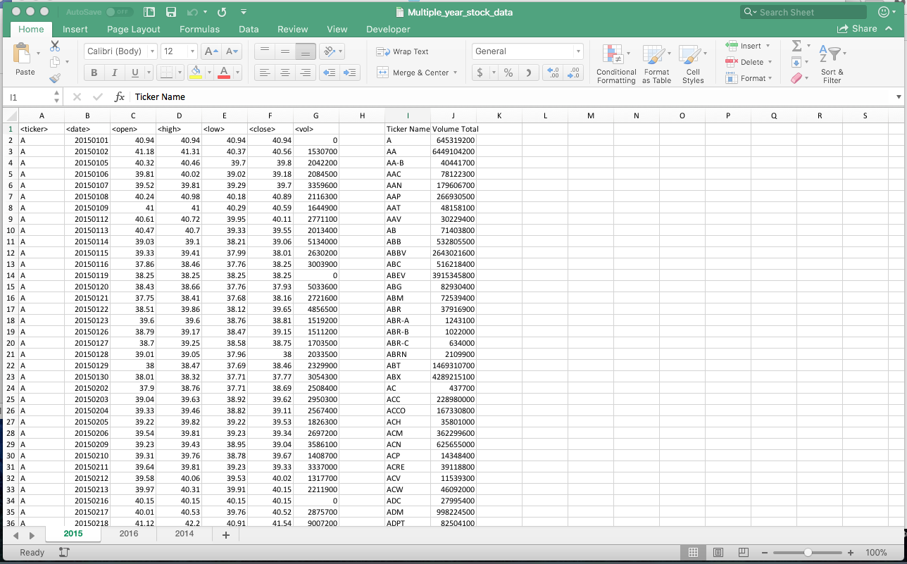

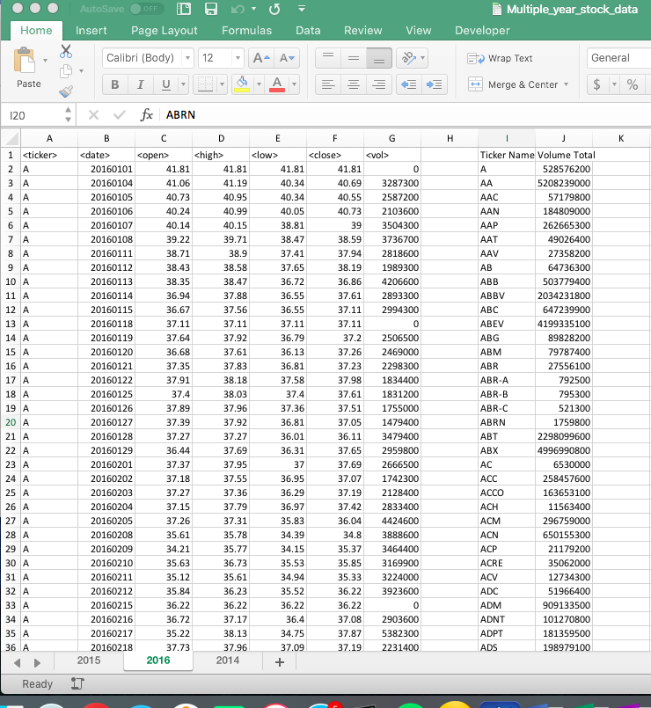

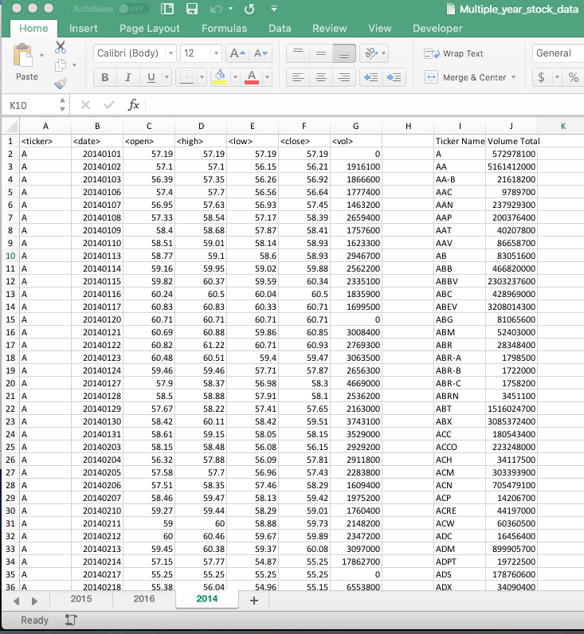

Code

Function loopAcrossSheets()

'Purpose of this function is to call and run the sub routine tickerSummary across all sheets

'Declare worksheets

Dim tempSheet As Worksheet

'loop through each spreadsheet and call for the subroutine

For Each tempSheet In Worksheets

tempSheet.Activate

Call tickerSummary

Next tempSheet

End Function

Sub tickerSummary()

'Purpose of this module is to calculate the total volume by each ticker

'declare variables

Dim tickerName As String

Dim volTotal As Double

Dim tickerTable As Integer

'set fixed values, ranges, name cells

volTotal = 0

tickerTable = 2

lastRow = Cells(Rows.Count, "A").End(xlUp).Row

Cells(1, 9).Value = "Ticker Name"

Cells(1, 10).Value = "Volume Total"

'Loops through each row in the ticker information until the ticker name changes

'once it has found the next ticker name it will calculate the volume by ticker

For I = 2 To lastRow

If Cells(I + 1, 1).Value <> Cells(I, 1).Value Then

tickerName = Cells(I, 1).Value

volTotal = volTotal + Cells(I, 7).Value

Range("I" & tickerTable).Value = tickerName

Range("J" & tickerTable).Value = volTotal

tickerTable = tickerTable + 1

volTotal = 0

Else

volTotal = volTotal + Cells(I, 7).Value

End If

Next I

End Sub